 **The First Table Tennis Competition**

**for Westlake Undergraduates**

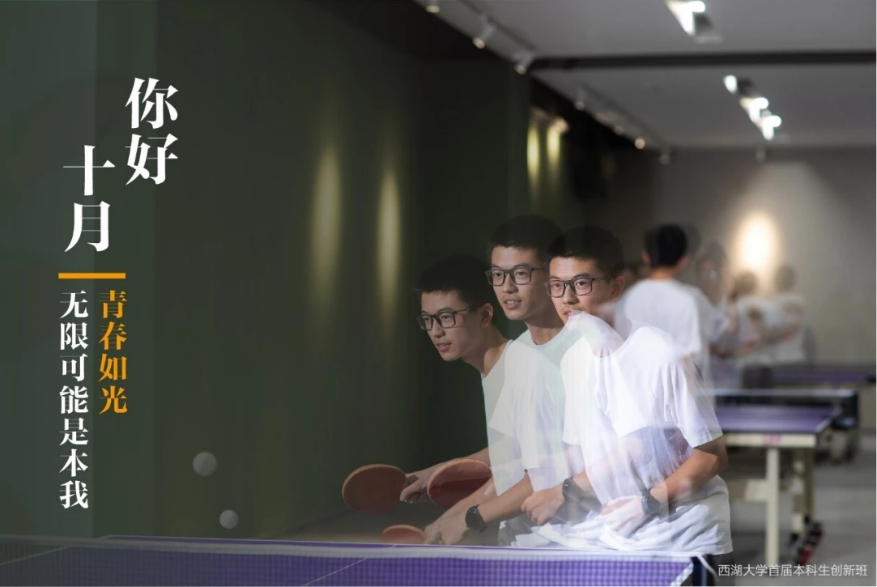On September twenty-fifth, the first table tennis competition for Westlake undergraduates, arranged by γ college, was successfully held and our α college got a satisfactory success.

This time’s competition contained five parts: men’s singles, women’s singles, men’s doubles, mixed doubles and funny competition. The first was men’s singles. Our contestants were Gehua Wen and Shengtao Hu. Gehua Wen rapidly defeated his opponent, while Shengtao Hu regretfully lost after three game matches. And finally, Gehua Wen got the second place.

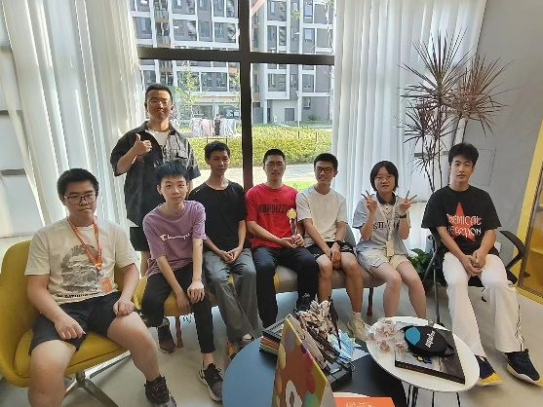 Then it was turn to girls. Shuleyi Zheng, the only girl in our college, went to battle in a cloak. Despite the huge gap between her and the opponent, she never gave up and fought for two game matches. In the afternoon, our college’s mixed doubles, men’s doubles and funny games all gained champions!

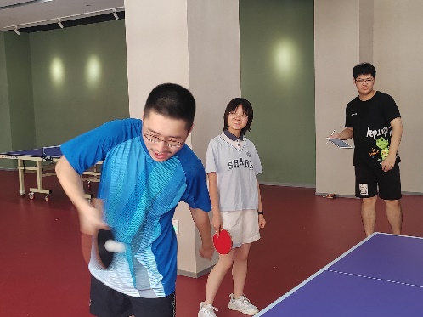 Finally, our college successfully got the championship of four colleges. Hope we can get better grade next year.